3.3.3.4.4 Tessellation
# Source: AI Source: Provided by: [Data Path: Persons Table -> ID Column: 1, Name_En Column: Motasem Essam] -> From: [ChatGPT] on [7/25/2026]
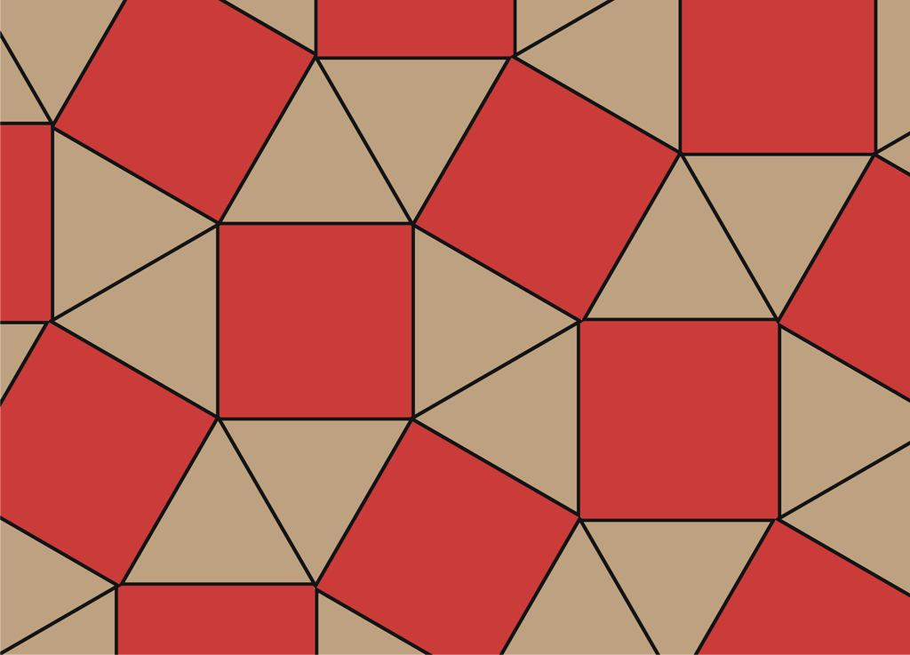
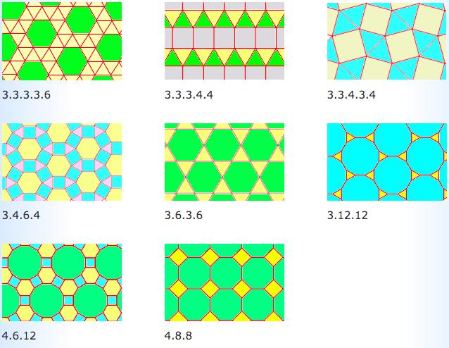
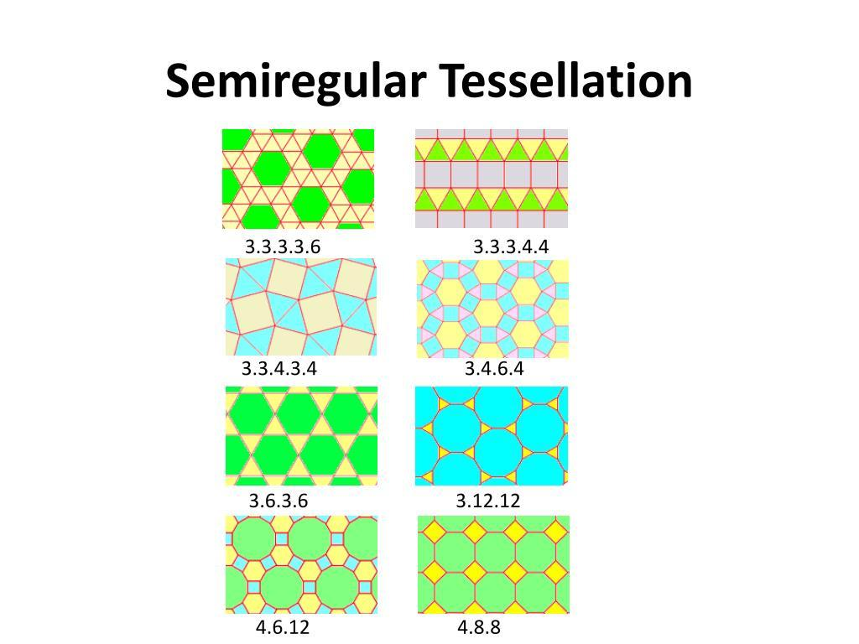

Definition
# Source: AI Source: Provided by: [Data Path: Persons Table -> ID Column: 1, Name_En Column: Motasem Essam] -> From: [ChatGPT] on [7/25/2026]
The $3.3.3.4.4$Tessellation is a semi-regular (Archimedean) tessellation composed of equilateral triangles and squares.
The vertex configuration
$$\boxed{3.3.3.4.4}$$
means that three equilateral triangles and two squares meet at every vertex, in that cyclic order.

Vertex Configuration
# Source: AI Source: Provided by: [Data Path: Persons Table -> ID Column: 1, Name_En Column: Motasem Essam] -> From: [ChatGPT] on [7/25/2026]
$$\boxed{3.3.3.4.4}$$
The numbers represent the number of sides of the polygons surrounding each vertex:
3 → 3 → 3 → 4 → 4
Therefore:
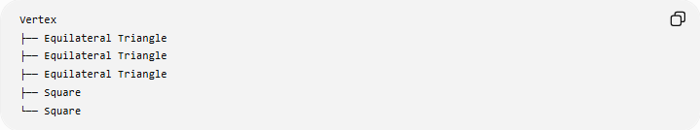
Vertex
├── Equilateral Triangle
├── Equilateral Triangle
├── Equilateral Triangle
├── Square
└── Square

Angle Verification
# Source: AI Source: Provided by: [Data Path: Persons Table -> ID Column: 1, Name_En Column: Motasem Essam] -> From: [ChatGPT] on [7/25/2026]
Each equilateral triangle has an interior angle of:
$${60}^{∘}$$
Each square has an interior angle of:
$${90}^{∘}$$
Therefore, around each vertex:
$${60}^{∘}+{60}^{∘}+{60}^{∘}+{90}^{∘}+{90}^{∘} \\ ={180}^{∘}+{180}^{∘} \\ \boxed{={360}^{∘}}$$
Thus, the polygons fit exactly around every vertex.

Fundamental Elements
# Source: AI Source: Provided by: [Data Path: Persons Table -> ID Column: 1, Name_En Column: Motasem Essam] -> From: [ChatGPT] on [7/25/2026]
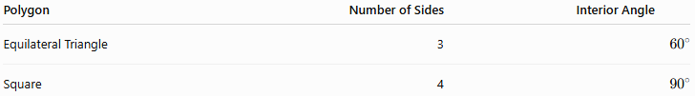
Polygon | Number of Sides | Interior Angle
Equilateral Triangle | 3 | $${60}^{∘}$$
Square | 4 | $${90}^{∘}$$
At each vertex:
$$\boxed{3\text{ triangles}+2\text{ squares}}$$

Why It Is Semi-Regular
# Source: AI Source: Provided by: [Data Path: Persons Table -> ID Column: 1, Name_En Column: Motasem Essam] -> From: [ChatGPT] on [7/25/2026]
It is not a regular tessellation because it uses two different types of regular polygons:
$$\boxed{\text{Equilateral Triangle}+\text{Square}}$$
It is semi-regular because:
- Every tile is a regular polygon.
- The same vertex configuration occurs at every vertex.
- The polygons completely cover the plane.
- There are no gaps or overlaps.

Vertex Configuration
# Source: AI Source: Provided by: [Data Path: Persons Table -> ID Column: 1, Name_En Column: Motasem Essam] -> From: [ChatGPT] on [7/25/2026]
The notation can also be written as:
$$\boxed{3^{3}{.4}^{2}}$$
Both notations describe the same vertex configuration:
$$\boxed{3.3.3.4.4=3^{3}{.4}^{2}}$$
The expanded form is particularly useful when you want to see the exact cyclic sequence.

Symmetry
# Source: AI Source: Provided by: [Data Path: Persons Table -> ID Column: 1, Name_En Column: Motasem Essam] -> From: [ChatGPT] on [7/25/2026]
The $3.3.3.4.4$tessellation has:
- Translational symmetry
- Rotational symmetry
- Reflection symmetry
It is therefore also a periodic tessellation.
Its combined classification is:
$$\boxed{\text{Semi-Regular + Periodic}}$$

Comparison with $3.3.4.3.4$
# Source: AI Source: Provided by: [Data Path: Persons Table -> ID Column: 1, Name_En Column: Motasem Essam] -> From: [ChatGPT] on [7/25/2026]
These two tessellations use exactly the same types and numbers of polygons at each vertex, but their cyclic arrangements are different.
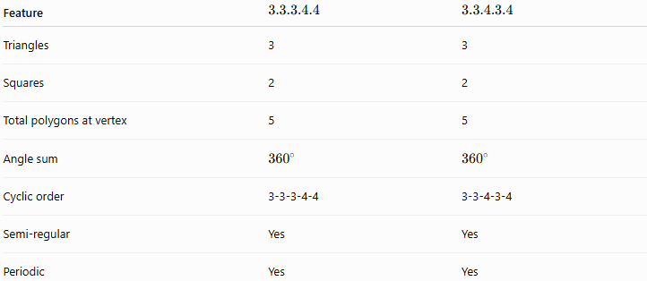
Feature | $$3.3.3.4.4$$ | $$3.3.4.3.4$$
Triangles | 3 | 3
Squares | 2 | 2
Total polygons at vertex | 5 | 5
Angle sum | $${360}^{∘}$$ | $${360}^{∘}$$
Cyclic order | 3-3-3-4-4 | 3-3-4-3-4
Semi-regular | Yes | Yes
Periodic | Yes | Yes
The distinction is therefore not just the number of each polygon, but also their order around the vertex.

Relationship to the Regular Tessellations
# Source: AI Source: Provided by: [Data Path: Persons Table -> ID Column: 1, Name_En Column: Motasem Essam] -> From: [ChatGPT] on [7/25/2026]
The $3.3.3.4.4$tessellation combines two polygons that independently form regular tessellations:
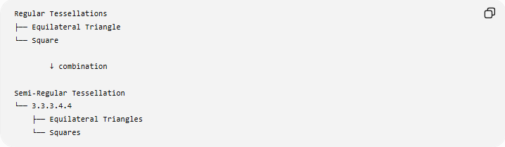
Regular Tessellations
├── Equilateral Triangle
└── Square

↓ combination

Semi-Regular Tessellation
└── 3.3.3.4.4
├── Equilateral Triangles
└── Squares

Classification
# Source: AI Source: Provided by: [Data Path: Persons Table -> ID Column: 1, Name_En Column: Motasem Essam] -> From: [ChatGPT] on [7/25/2026]
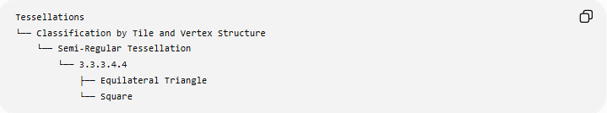
Tessellations
└── Classification by Tile and Vertex Structure
└── Semi-Regular Tessellation
└── 3.3.3.4.4
├── Equilateral Triangle
└── Square
And independently:
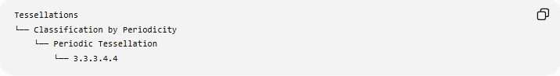
Tessellations
└── Classification by Periodicity
└── Periodic Tessellation
└── 3.3.3.4.4

Key Points
# Source: AI Source: Provided by: [Data Path: Persons Table -> ID Column: 1, Name_En Column: Motasem Essam] -> From: [ChatGPT] on [7/25/2026]
$$\boxed{3.3.3.4.4}$$
- Uses equilateral triangles and squares.
- Three triangles and two squares meet at each vertex.
- The angles are:
$${60}^{∘}+{60}^{∘}+{60}^{∘}+{90}^{∘}+{90}^{∘}$$
- Their total is:
$$\boxed{{360}^{∘}}$$
- It is a semi-regular (Archimedean) tessellation.
- It is also periodic.
- Its equivalent compact notation is:
$$\boxed{3^{3}{.4}^{2}}$$
- It is distinct from $3.3.4.3.4$because the cyclic order of the polygons differs.

